1.**Http\Requests\ApiRequest.php (just copy from lesson)**

2.**Http\Controllers\Back\ApiController.php (code copy from lesson)**

use App\ {

Http\Controllers\Controller,

Repositories\AdminRepository**,**

**Http\Requests\ApiRequest**

};

**use Validator;**

/**

* Store a newly created apimessage in storage.

*

* @param \App\Http\Requests\ApiRequest $request

* @return \Illuminate\Http\Response

*/

//public function store(Request $request)

public function **store(ApiRequest $request)**

{

**if(isset($request->validator) && $request->validator->fails()) //if you need validator->errors() for ApimessageRequest $request + see in ApimessageRequest**

**{**

**return $request->validator->errors(); //{"message":["The message field is required."]}**

**}**

**return json_encode($this->repository->storeapi($request)); //true or false (will be ->save() in Repository, create – won’t be because $request->apitoken is not used)**

}

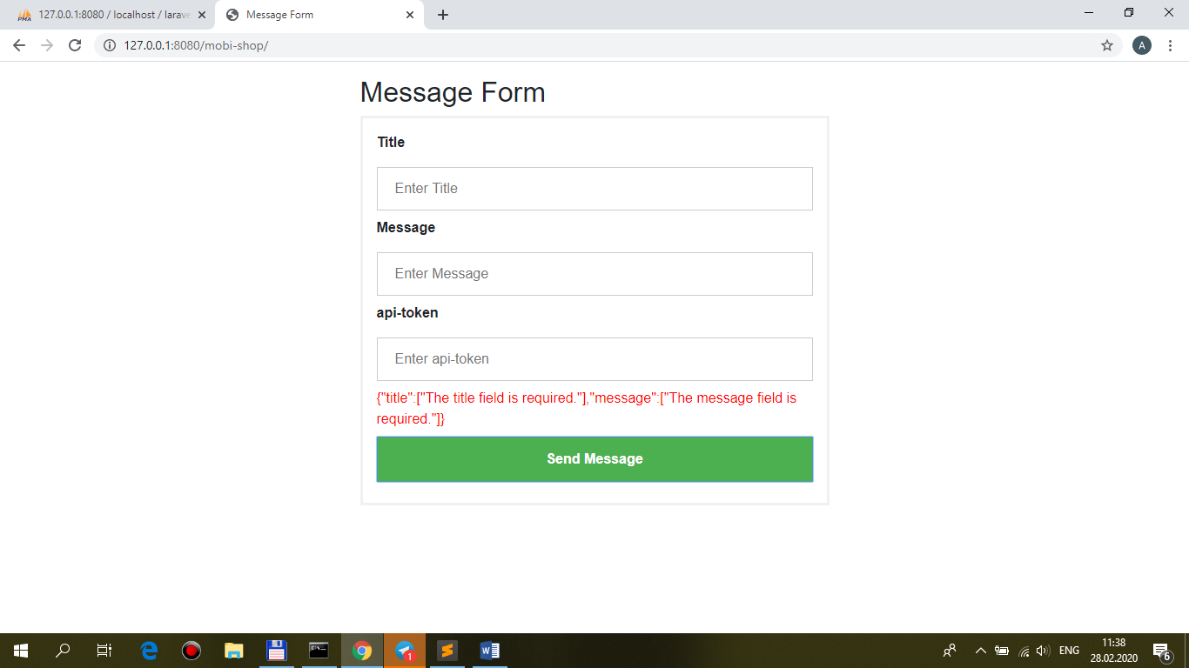

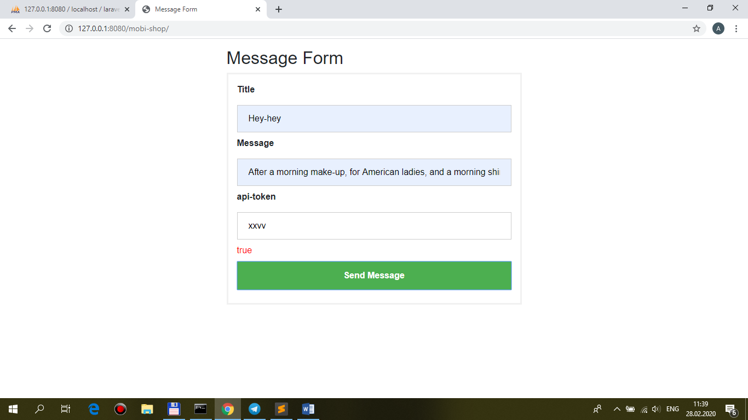

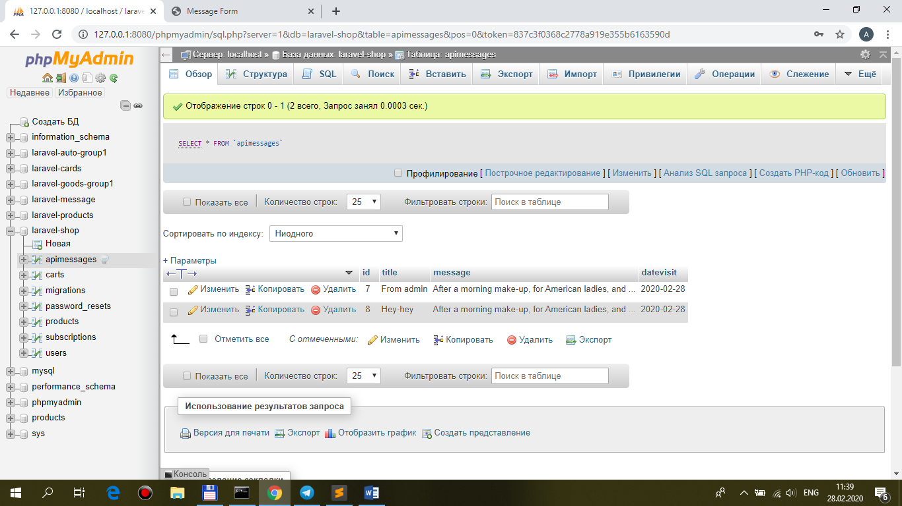

2.routes\api.php

Route::name('apimessages')->**middleware('auth:api')**->resource('apimessages', 'Back\ApiController');

//Route::name('apimessages')->resource('apimessages', 'Back\ApiController');

**database/migrations/...create_users_table.php**

+ $table->string('api_token')->unique();

**database/seeds/DatabaseSeeder.php**

for User + 'api_token' => str_random(8),

**remove all tables from DB**

+ php artisan migrate --seed

**in users-table see api_token for alex (for example jW3UMWEe)**

**mobi-shop/Api.php**

public function **mailerMessage**($title, $message, **$apitoken**)

{

...

$response = $client->request('POST', 'http://laravel-message/api/apimessages**?api_token=' . $apitoken**, [

'form_params' => [

'title' => $title, //title, message

'message' => $message,

**//**'apitoken' => $apitoken,

'datevisit' => date('Y-m-d'), //+datevisit - Y-m-d

]

…

**mine.js**

success: function(data){

//alert(data);

//$('.red').html(data);

**if(data=='true')** {

$('[name="title"]').val('');

$('[name="message"]').val('');

$('[name="apitoken"]').val('');

alert('Your message has been successfully sent...');

}

else alert('Your token is bad or there is(are) empty field(s)...');

},

-error **api-token**:

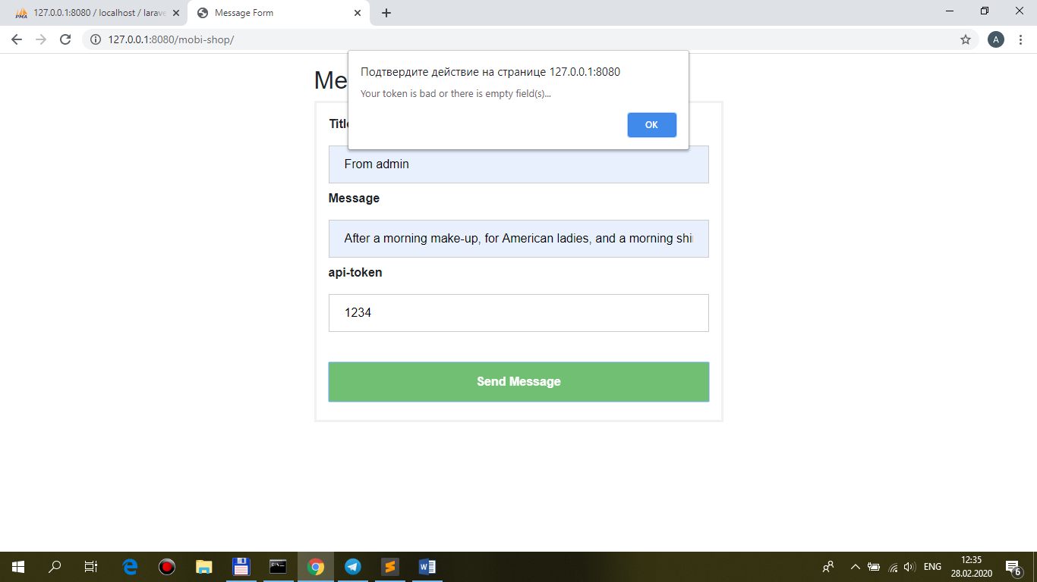

-error **validation**:

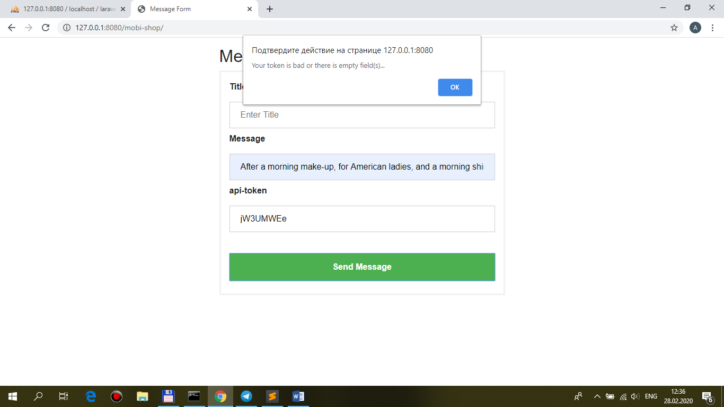

-**success** api-token and validation:

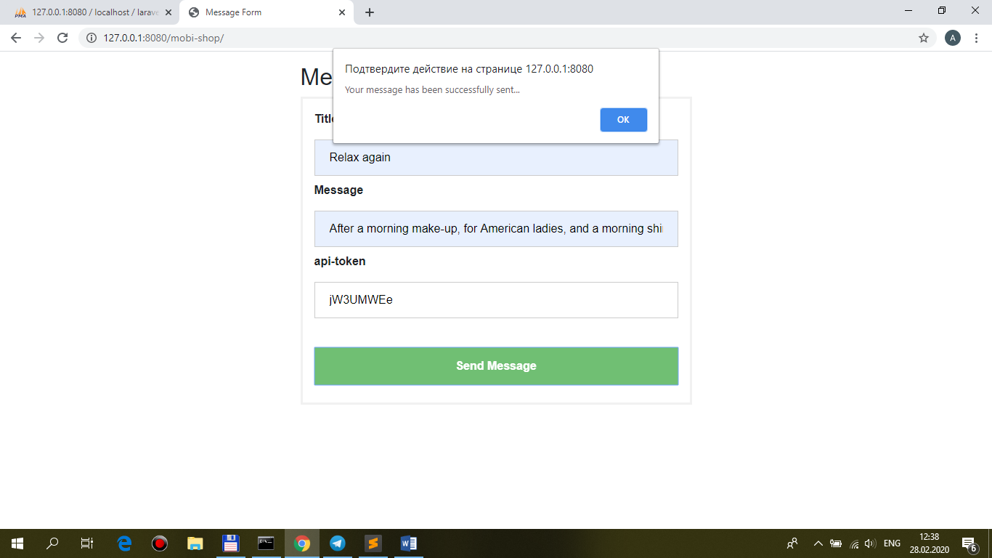

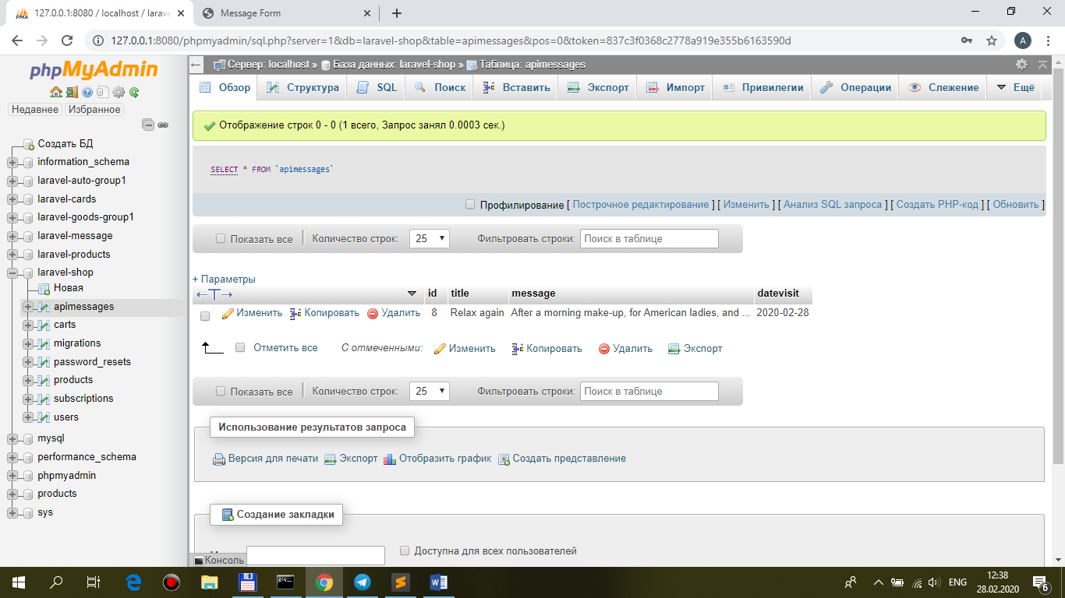

3.**And Who has that been?**

**database\migrations\..._apimessages.php**

+ $table->integer('user_id')->unsigned()->index();

**2019_02_06_082606_create_foreign_keys.php CODE copy from laravel-cards**

public function up()

{

Schema::table('**carts**', function(Blueprint $table) {

$table->foreign('user_id')->references('id')->on('users')

->onDelete('cascade')

->onUpdate('cascade');

});

Schema::table('**apimessages**', function(Blueprint $table) {

$table->foreign('user_id')->references('id')->on('users')

->onDelete('cascade')

->onUpdate('cascade');

});

}

public function down()

{

Schema::table('**carts**', function(Blueprint $table) {

$table->dropForeign('users_user_id_foreign');

});

Schema::table('**apimessages**', function(Blueprint $table) {

$table->dropForeign('users_user_id_foreign');

});

}

**remove all tables + php artisan migrate --seed**

**+**

**see new api_token → then enter in mobi_shop\Api.php (for example YQzJbBpf)**

**app\Models\Apimessage.php**

protected $fillable = [

**'user_id',** 'title', 'message', 'datevisit',

];

**/\*\***

**\* One to One relation**

**\***

**\* @return \Illuminate\Database\Eloquent\Relations\belongsTo**

**\*/**

**public function user()**

**{**

**return $this->belongsTo(User::class);**

**}**

**app\Repositories\AdminRepository.php**

public function storeapi($request)

{

**$this->model_apimessage->user_id = \Auth::guard('api')->user()->id;**

…

}

